
CATHOLIC WOMEN’S LEAGUE OF AOTEAROA NEW ZEALAND
Te Ropu Wahine Katorika o Aotearoa
WELLINGTON ARCHDIOCESE: NEWSLETTER: NOVEMBER 2020
Dear Branch Members
BRANCH ANNUAL GENERAL MEETINGS A big thank you to all Members who stepped up to take on a role for the forthcoming year.

REFLECTION DAY It was wonderful to see in excess of 80 women attend the Archdiocesan Council-organised Day of Reflection ‘Living in Gratitude’ facilitated by Joy Cowley at the Our Lady of Grace Church. A big thank you to the Chaplain Christine Paterson ably assisted by Kathleen Emmerson for all the organisation work to ensure the success of the day. Great to have National President Susan Dickson join us all the way from her home in Methven. Eight women travelled from their New Plymouth and Inglewood Branches to be with us at the Reflection Day. A special thanks to our ladies who billeted them. The day was split into three sessions: Women in the Gospel, Women in the Church, Women in the World. Joy opened up our thinking about these topics with humour, discussion and personal reflection. A wonderful end to the unprecedented year of change we’ve all had to endure.


77th WELLINGTON ARCHDIOCESAN CONFERENCE 2021 Thursday, 18 March 2021 @ Our Lady of Kapiti Centre, Paraparaumu. Branch and Individual Registration forms have been circulated. We have finalised a School Debate between two Teams from Bishop Viard College on our Theme of Kia Kaha – Courage, Take Heart. It is that time of the year that we should be thinking about who you want on your Archdiocesan Council. Members of our Council shall be elected, appointed or co-opted annually. At Conference we are to elect a President. Special Officers (WUCWO Convenor, Mission Convenor and Social Issues Convenor) are to be co-opted by Council and confirmed at Conference. Regional Representatives are to be appointed by Regions and also confirmed at Conference. The maximum period of consecutive service for these positions on the Council shall be ordinarily four years in any one position. Christina Dwyer completes her four years of worthy service as our WUCWO Convenor at the Conference next March. Branches are invited to submit their nomination to the Archdiocesan Secretary for the position of President at least two months before Conference, and to indicate to Council names of members known to be interested in being considered for any of the Special Officer positions, in time for the Council to take into account at its meeting on 5th February 2021.

AT HOME APPEAL 2021 It is time for Branches to discuss organisations that our Archdiocesan Council can consider. Please submit these to the Archdiocesan Secretary or Mission Convenor by 17th November for the Council to consider with a view to putting forward to the National Board early in 2021.

THANKS FROM ARCHDIOCESAN COUNCIL As we reflect back on the trying times of the past year, it is appropriate that we recognise the valuable contributions that many of our members have been able to provide to our Branches and within their Parishes. It may not have been easy, but the strength of character shown, and the valuable support provided to each other and in particular those more vulnerable than ourselves is worth noting. Christine Paterson’s message on the second page of this Newsletter is extremely relevant as we move into 2021.


Merry Christmas and a Happy New Year
May God’s graces and blessings be bestowed upon you all in abundance.
Susan Lloyd, Archdiocesan President

MISSION I have been reading the “CWL National History 1931 – 1990” which tells me that CWL involvement with the missions has grown organically from the support that groups of women in the parishes gave to their local clergy and religious, such as the traditional “pantry appeals.” As New Zealand children of these women went into missionary work they too were supported. It is natural that once CWL was started in New Zealand its members would be involved in this work. When the big city Branches were split up and based in Parish and, the National Board appointed a National Mission Secretary Mrs Cath Davis, the present system was set up with her guiding hand. Branches were given designated Mission Communities in the Pacific and sometimes a Maori Mission in New Zealand too. The tradition of giving to local clergy and religious persist as is shown on the annual Mission Return Form. From the earliest days, communication problems existed with the Pacific communities.
Christmas is famously a time of giving. Giving gifts was part of the celebrations long before Christmas became a secular commercial festival. In the 19th century Queen Victoria’s children had a Christmas tree and domestic servants were given new clothes or cloth to make up. It isn’t what is given or received that counts but the kindness and concern that is behind the gift. Times have changed from the early days of CWL Mission giving. Then second-hand clothing and sewing machines were freighted: now we send money by electronic banking, which allows the Mission Communities to decide their own priorities. Recently attention has come back into New Zealand with gifts of food and warm clothes to low decile schools.
Christmas originated with European early Christians borrowing the Roman saturnalia so many traditions of food and ceremonies suited short, cold days. They have been adapted here – BBQ instead of Yule log for example. It is still a festival focused on family and the community. We still sing carols and feast on rich foods. Branches could ask their Mission Communities “what are your local ways of celebrating Christmas”, and, in these days of email and cell-phones, an exchange of photographs is possible. Something new for your branch to try?
Anne Lumb, Archdiocesan Mission Convenor
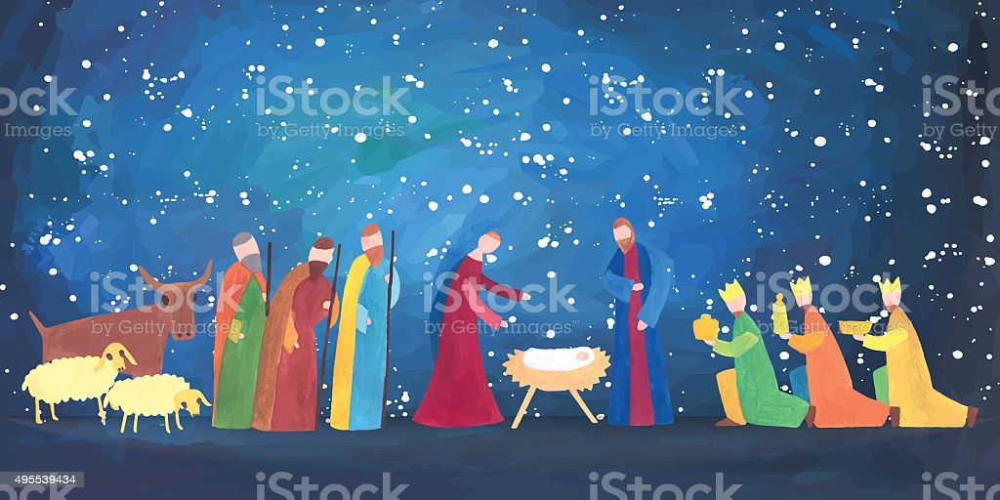


If you see someone falling behind, walk beside them.

If you see someone being ignored, find a way to include them.
Always remind people of their worth.
One small act could mean the world to them.
Christine Paterson, Archdiocesan Chaplain

