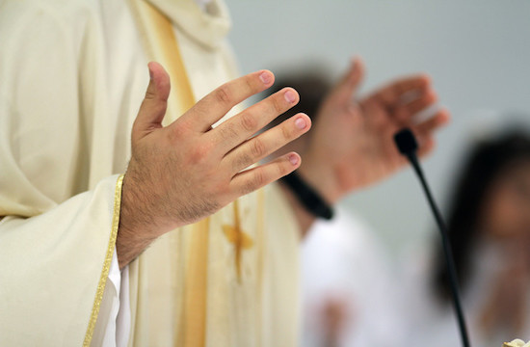
Stop calling me 'Father'!

The practice of calling priests 'Father' can be unhealthy when it is the expression of an emotional dependence based on a false idea of obedience

Jean-Pierre Roche
France
March 29, 2019

Many Catholics are overwhelmed, shocked and appalled. They are traumatized by the sex abuse crisis that is tainting their Church. And so am I. But what can we do?
Above all, we must express our compassion and empathy for the victims, whose suffering is much greater than ours.
This crisis demands that we transform the Church, which is made up of us all. This transformation can only happen by returning to the Gospel, but it must also involve tangible changes in the ways in which we live in the Church and society.
Last August, Pope Francis wrote to all of God's people, appealing to them to take action against clericalism, which he perceives as the source of the abuse perpetrated by priests, bishops and religious superiors.
I hope to add my modest part to his appeal.

At least three reasons not to call me "Father"

The Christians with whom I work and those I guide call me naturally by my first name, my baptismal name.
However, all the Catholics I meet on Sundays, in the different churches in my community, or during baptisms, marriages and funerals, call me "Father." This is also true of the townspeople, who are not particularly Christian but who feel obliged to address me in this way.
This has bothered me during the almost twenty years that I have been a priest. However, in today's context when we know that certain priests have been found guilty of the sexual abuse of children or nuns, I believe it is urgent that I ask of you: Please, do not call me "Father"!

I do so for at least three reasons.

— The first reason should be sufficient in itself, as it is found in the Gospels. Priests wish to be disciples of Jesus, who said, "You are not to be called 'Master,' for you have but one Master, and you are all brothers and sisters. And do not call anyone on earth 'Father,' for you have but one Father, who is in Heaven" (Mt 23: 8-9).
Sometimes Jesus' words are difficult to interpret, but the meaning of these is particularly clear. To be called "Father" is, quite frankly, to usurp the place of God, the Father of all people. It is, literally, to play God!

Not children, but brothers and sisters

— The second reason is that calling priests "Father" infantilizes Catholics. How is it possible to have fraternal relationships between adults who are equals, if we are all brothers and sisters except for one person -- the one we call "Father"? How do we dare express disagreement if, in doing so, we must "kill the father"?
Catholics are not children who have to say "amen" each time the priest has spoken.
If the Church wants to once again be a fraternity, we must stop this custom, and should put into practice the beautiful passage from the Vatican Council II: "Even though some, by the will of Christ, are made doctors and pastors for the good of others, in terms of the dignity and activities of all the faithful in the edification of the Body of Christ, there is true equality among all."
I understand that priests exercise a sort of spiritual fatherhood. But I can say that those who see me as their spiritual guide never call me "Father."
So, is it to somehow compensate for not having children that priests let themselves be called "Father"?
What helps me to live my celibacy, is that the fact that my mission has given me many friends. They are not children, but rather brothers and sisters. Isn't this what priests call us when they say, "Dear brothers and sisters"?
As for my brothers who are bishops (for whom I am saying many prayers at present), I leave it to them to ask you to no longer call them "Monsignor" or "My Lord". I find this particularly shocking, as we have only one "Signor" / "Lord". And it's not our bishop.
— Finally, the practice of calling us "Father" can, quite frankly, be unhealthy when it is the expression of an emotional dependence based on a false idea of obedience.
Fatherhood is, in effect, a mixture of affection and authority. But it can be dangerous, especially if it is made sacred.

An absolute monarchical power of masculine, divine right

So, please, stop calling us "Father." If you don't know us well enough to call us by our first name, call us "brother Joseph" or simply "brother", just as you say, "Sister Nicole" or "sister."
This will be your contribution to the battle against the clericalism that is at the origin of all the abuse in the Church.
You might think this is just a small thing. An that's true. But, while we wait for the Church to be reformed, maybe we can begin to change such small things.
I am not sure that our Church can, in the light of the Gospels, cut corners in its careful consideration of its governance and organization.
Catholics, who are always told – and rightly so – that they are the Church, will have more and more difficulty in supporting the clerical authority of priests, bishops and the pope, as long as it remains an absolute monarchical power of masculine, divine right.
The Church is an increasingly incomprehensible organization in our democratic, pluralist and egalitarian society.
In the meantime, maybe we can all take this small step forward in building a more fraternal Church.

Jean-Pierre Roche is a priest and popular author from the Diocese of Créteil, just south of Paris.

