ST. JOSEPHINE BAKHITA AND THE DOOR TO HOLINESS
by Rozann Lee February 08, 2018

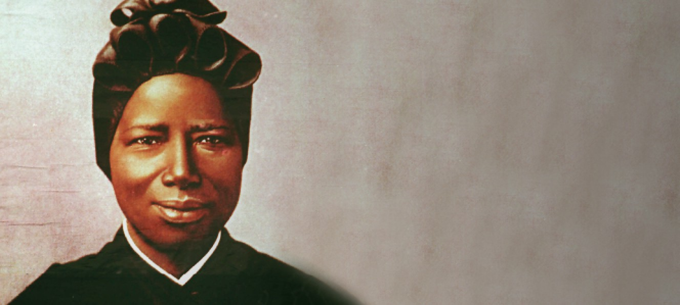

Today, the Church honors St. Josephine Bakhita (1869-1947), a Sudanese woman who was sold into brutal and abusive slavery as a young girl in the Darfur region of Africa, eventually transported to Italy to work for a friend of her owner’s family, and, when she resisted returning to Africa in favor of joining the religious order who taught the young daughter of the family for whom she worked, was set free because of the dictates of Italian law. After professing eternal vows, she lived out the remainder of her life as a Canossian Sister of the Institute of Catechumens in Venice, Italy. St. Josephine was canonized by Pope John Paul II in 2000 and is recognized as the patron saint of Sudan. According to the existing accounts of her life, there are two prominent bits of biographical history that are attributed to St. Josephine. One is this beautiful quotation: “Be good, love the Lord, pray for those who do not know him. What a great grace it is to know God!” The other is that, amongst the Canossian Sisters in Venice, St. Josephine’s mission was carried out in the services of “cooking, sewing, embroidery and attending the door.”
That is all.
No literary works are attributed to Josephine Bakhita, few quips of theological genius carry her citation, no major religious orders or movements memorialize her earthly existence. In the same vein as the beloved St. Thérèse of Lisieux, Josephine was a saint of the “little way,” even littler still. She is a saint of almost-unnoticed holiness. Almost. Cooking, sewing, embroidering, and attending the door, she carried out joyfully the call of Christ in the small tasks of a menial, yet eternally important life: every child who entered in through that door to be educated by the Canossian Sisters received the warm welcome of St. Josephine, a hearty hug and a kiss on the top of the head, her love overflowing and her spirit carrying Christ to all who crossed that threshold.
We know that the Church celebrates the tradition of the saints in order that we might point to tangible examples of the universal call to holiness uniquely expressed. She lifts up these individuals to serve as spiritual models, that we might see and cultivate within ourselves what Christ sees and loves in these “good and faithful” servants who, even now, gaze upon his face and carry our own prayers to his ears when our human limitations prevent us from offering these prayers unceasingly. At the risk of sounding clichéd, St. Josephine stands as an example of the reality that holiness is not in a typified path or a chosen vocation with benchmarks of particular spiritual disciplines and practices. It is constant conversion, constant love, and constant self-gift, not striving for ever-greater notoriety in good deeds, but in disappearing into the mission of the Church … in self-forgetfully “attending the door.”
Many of us can relate to the simplicity of this path to holiness. It hearkens back to Saint Teresa of Calcutta’s words: “In this life, we cannot do great things. We can only do small things with great love.” Our daily lives, the place wherein our vocation is actualized, provide countless opportunities to exercise this great love if we will only recognize them as such. This reality has become greeting-card-familiar, and thankfully so. However, the fundamental shift on the true path to holiness lies in, as is customary, a paradox: we are most powerfully affected by the model of the almost-unnoticed holiness of St. Josephine Bakhita—not in using her example as a means to justify the beauty of our own “almost-unnoticed” holiness, and not in celebrating the small, humble nature of our own lives and finding solace in the simplicity of our path to holiness. It's not really in relating ourselves to St. Josephine at all.
It is, however, in forgetting our holiness altogether—unnoticed, simple, devout, greatly celebrated, or otherwise. It’s not in seeking explicitly to follow in the simple footsteps of a humble sister from Darfur for the sake of our own sanctity; it is, rather, in stopping for a moment by the person guarding the door … and greeting St. Josephine. (What we wouldn’t give to walk through that door; to speak, for just a moment, to one whom we were certain would soon be speaking directly to Christ, face-to-face, on our behalf!) The greatest spiritual insight to carry from a living, breathing, communicable relationship with the community of saints, as well as from the almost-unnoticed sanctity of St. Josephine Bakhita, is to see this very community living all around us—and then to actualize this sanctity in others by believing with every fiber of our being that it exists. That is dignity. That is holiness. That is transformative.
Thomas Merton, in Conjectures of a Guilty Bystander, said: “There is no way of telling people that they are all walking around, shining like the sun.” However, it becomes clear that despite this impossibility, a life spent discovering and celebrating this luminosity in others has the unintended consequence of turning the discoverer into one who loves beyond measure, a “sun” with a similar radiance to that of St. Josephine Bakhita. Love is the result of a willful action, and holiness is the result of love. Let us love as she did, and let our own holiness be realized only by those for whom we hold the door.
In addition, St. Josephine serves as a powerful intercessor for the deeply persecuted Christian population of Sudan. Today’s feast day is a valuable reminder that the Church is constantly being persecuted. For most Christians, this state of being is the status quo. Let us fervently implore the intercession of St. Josephine on behalf of these persecuted Christians all over the world.



ROZANN LEE
CREATIVE DIRECTOR AT WORD ON FIRE.
Rozann Lee is the Creative Director at Word on Fire Catholic Ministries. In 2005, she graduated from the University of Notre Dame with dual degrees in Graphic Design and Theology. She currently lives in downtown Chicago with her husband, Sean Lee, who conveniently also works at Word on Fire.
https://www.wordonfire.org/resources/author/rozann-lee/8396/

