Catholic Women’s League New Zealand
Te Ropu Wahine Katorika o Aotearoa.
Wellington Archdiocesan Council

PRESIDENT’S NEWSLETTER, June 2018
The month of May has been marked with Prayer and Liturgies prepared by WUCWO for the women of the world. Most Branches used this as an opportunity to gather together to pray, finding inspiration in the prayers.
CWL members farewelled recently are Judith Curry, Heretaunga, Margaret de Joux in Otari. Cath Hewson (Lower Hutt). May you rest in peace. Deceased members of CWL, 2016 – 2018 will be commemorated during the National Conference. Please send me the names and Branch, of your Members who have graduated to their glory, by the 30th June. These will be forwarded to Sr John Bosco, CWLANZ Chaplain.
National Conference provides us with a wonderful opportunity to meet and spend time with our New Zealand and Australian colleagues, to familiarise ourselves with the new Theme - Women Welcoming Change – to meet to discuss issues and concerns, and to step outside of our everyday happenings, to facilitate reflection. The Opening Mass will be celebrated on Wednesday evening 25th July, by Cardinal John Dew. The Thursday Keynote Speaker is Ann Dickinson, launching our new Theme; we will hear Reports from our Social Issues Officer, WUCWO Report, Diocesan Reports, a Panel on Journeys, and the Pilgrimage to the Home of Compassion to reflect on the life of the Venerable Suzanne Aubert. We invite all CWL members to be part of the National Conference. The Agenda has been circulated. Please let me know if any problem with the distribution of the Conference Programme occurs.
Billets may be needed for late enrolments for the National Conference. None of our Wellington branches are based in the vicinity of the Brentwood, so transport could be an additional need. If you could provide for a visitor, please let me know your contact details.
As the hosting Region, Otari and Onslow Branches are currently deciding on dates and venue for the Wellington Regional Conference, 2019. There have been suggestions that we have a Friday afternoon and Saturday Conference this time - or perhaps Saturday-Sunday morning. We are trying to arrange the Wellington AGM and Conference for the 30th March, 2019 and will keep you informed about this.
Have you ever looked at pages 6 and 7 at the front of the Phone Book? Listed there are the names and contact numbers of Personal Help Services, ranging from Emergency contacts, through Counselling and Advice and Health Services, all covering a range of support services for all ages and stages and needs. I recommend this as a very valuable resource for families, for supporting and advising those in need and for general knowledge of community support available and how to access it.
Some Council members took Sr Bernadette Rodgers to lunch at Limelight in Upper Hutt recently, to thank her for her time as Spiritual Leader for the Council, acknowledging Sr Bernadette’s contribution to the Council, with a Cyclamen plant.
Current issues to the fore, continue to be Abortion and Euthanasia, especially with the landslide vote in Ireland bringing this topic to media attention. On National Radio recently I heard an MP talk vaguely about a few thousand babies being aborted. When I looked up the official Statistics, the number is currently nearly 13,000 abortions a year, down from 19,000 in 2003. This is the ANNUAL figure, a lot more than “a few thousand”. Thanks, and blessings to our own Mothers for giving us this wonderful gift, our chance at life.
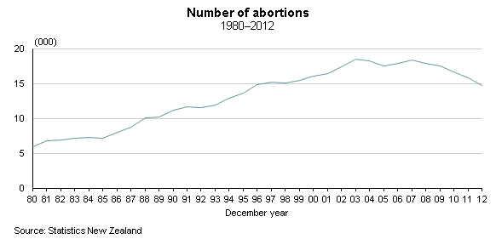
Around the Branches Notes from the Branch Reports indicate all the generous ways our Wonder Women members contribute their time and talents to Parish life. Some highlights to share and inspire are:
Levin – CWL members work with the Churches of the area, to run an Op Shop in the town, providing the opportunity to give new life and use to clothing and household items, each day. The Churches share the proceeds, which in turn benefits all the Churches, as well as CWL appeals and charities.
Kapiti – CWL members keep contact and communication operating and are in good heart, in spite of being without a Church building. They have a Mass base in the Hall of the new Catholic School, so the community comes together each Sunday, which must be very special for them. Let us pray that their new Church building will soon become a reality.
Onslow – Enjoyed the hospitality of Otari Branch for the WUCWO Day of Prayer. They plan an Anointing Mass for the sick of the Parish, at 2pm on Wednesday 20th June. The new Principal of St Benedicts School will speak to the next Social evening on 26th June.
Otari – Will begin their CWL Winter Series led by Susan Crisp, Spiritual Director, at 10am on Wednesday 20th June, exploring “Waiting for God” with reference to Sarah in Genesis 16.
Lower Hutt – Welcomed their Filipino community to their recent WUCWO liturgy, then heard about the culture and Faith practices of their homeland, followed by traditional food. CWL Lower Hutt will celebrate their special birthday with High Tea in Kaitoke.
Heretaunga - Members have been knitting 87 items including TV slippers, scarves and fingerless gloves for nearby Catholic schools, plus 15 pairs of baby bootees for Voice for Life. A Quiz Night with Upper Hutt will raise funds for Te Omanga Hospice on 29th June.
Upper Hutt – Provide soup and bread rolls for Teen Parents during the Winter. Members visit League Members in Rest Homes. A Parish family will visit the UH CWL Mission community on their visit to Tonga, in the near future.

Each and every one of you are amazing gifts to the Church of New Zealand, to CWLANZ and to each other bringing God’s love to all in your neighbourhood, through your thoughtfulness.

In Faith and Service.
May you be blessed in every way

Christine Paterson,
Archdiocesan President, Wellington

