
Catholic Women’s League of Aotearoa–New Zealand

1931 –

Catholic Women’s League of Aotearoa–New Zealand

1931 – Theme: Religion
Known as:
- Catholic Women's League of New Zealand 1931 – 2013
- Catholic Women’s League of Aotearoa–New Zealand 2013 –
This essay written by Christine Cheyne was first published in Women Together: a History of Women's Organisations in New Zealand in 1993. It was updated by Anne Lumb in 2018.

1931 – 1993
Although women have made such an important contribution to the Catholic Church and have generally outnumbered men in active parish life, by the 1990s there had been relatively few Catholic lay women's organisations. The main one, and the first such national body in New Zealand, was the Catholic Women's League (CWL). Indeed, in 1983 the league claimed that it was 'the major lay organisation in the Church both in numbers and activity'. [1] Membership consisted of 'predominantly middle-aged married Catholic women whose lives have centred around their homes and families, with the league being their "community outlet"'. [2] In 1992 there were approximately 5000 members in just over 150 branches.
The CWL first formed in England in 1906, but it was not established in New Zealand until 1931, when the Bishop of Auckland, James Liston, invited Catholic women to a meeting on 9 July, hoping they would form a league to undertake voluntary charitable work for the poor. Patronage by diocesan bishops was a continuing feature of the Catholic Women’s League of New Zealand (CWLNZ).
That first Auckland branch was followed by Christchurch (1936) and Wellington (1944). In the late 1940s steps were taken to establish a national body; this was achieved in December 1948, and a branch was formed in Dunedin in 1949, giving the league a presence in all four Catholic dioceses. The first national president was Kathleen O'Connor of Christchurch, and the first conference was held in Auckland in October 1949.
The founder of the English CWL, Margaret Fletcher, aimed 'to unite Catholic women in a bond of common fellowship for the promotion of religious, intellectual and social work'. [3] This theme of outward good works guided by spiritual belief, represented in the CWL motto, 'Faith and Service', was fostered by Bishop Liston and other founders of the league in New Zealand. There was a strong emphasis on social work and social reform from an ostensibly politically neutral basis. League activities included raising money for mission stations in the Pacific, and for Māori missions in New Zealand.
Initially, membership was open to 'practising Catholic women' who would promote the Catholic faith in the wider community; this was later modified so that non-Catholic partners of Catholic men could join. [4] Up to the early 1990s the league was overwhelmingly a Pākehā organisation, although there were some Māori branches. In the late 1970s, at the suggestion of the Bishop of Auckland, Māori women joined the league as a base for pastoral work and other activities among Māori. Despite this encouragement, the numbers of Māori members remained low.
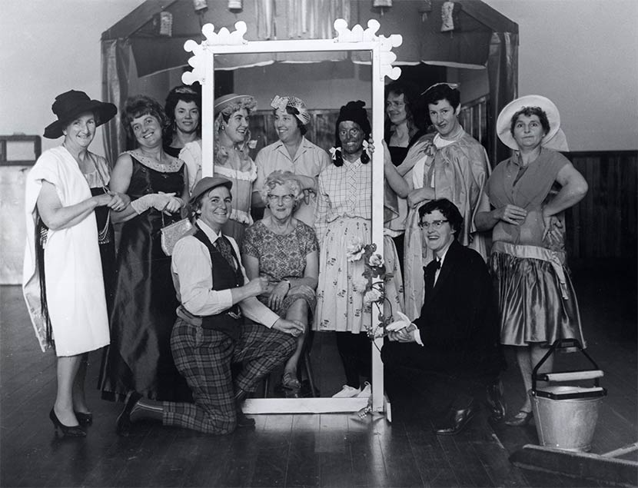
During the 1950s, league membership exceeded 12,000 and branches were extremely active; they formed 'circles' to meet special needs or interests, such as sewing, music, drama, and raising funds. In the late 1950s and 1960s, fundraising for missions became a major focus. There were regular conferences, and much effort went into studying, preparing remits, and taking part in the Church's ecumenical endeavours, both in New Zealand and abroad. Equally important were the prayer services and other liturgical events organised for particular causes.
These members of the Catholic Women's League singing group in Upper Hutt, north of Wellington, are dressed for a performance c. 1970. Pictured (from left) are: Evelyn Shannon, Pat Hudson, unidentified, Nora Weatherall, Noelene Quinn, Katlin Paques, Nellie Hudepol, Pat Venning, Mary Richardson, Eileen Foster, Val Kelly. Upper Hutt City Library Heritage Collections. Ref: P3-221-1305
In the early 1990s the CWLNZ continued to be organised hierarchically, with a national executive and biennial national conferences, as well as diocesan councils and annual diocesan conferences. Within dioceses, there was a regional structure. The lowest level of organisation was the branch, which was usually attached to a parish. The structure conformed closely with the organisation of the Catholic Church, and the league had a close relationship with the male clerical structure of the Church. This was reflected in the desire to be recognised by the bishop of each diocese and to have local clergy as branch chaplains. As a consequence, the league often deferred to male clergy and complied with their wishes. The local parish priest or branch chaplain frequently attended branch meetings.
Internationally the CWL became a significant organisation within the Catholic Church, as a channel for both a women's perspective on issues within the church, and a Catholic women's perspective on issues outside it. By 1993 the CWLNZ was affiliated to the World Union of Catholic Women's Organisations (formerly the International Federation of Catholic Women's Leagues), and also to the National Council of Women (NCW); it was represented on many other national bodies, including Church Women United of Aotearoa/New Zealand and the Pan-Pacific and South-East Asia Women's Association. At times, the league disaffiliated from other organisations because of its opposition to their policies and practices—for example, when CORSO decided to fund New Zealand groups rather than provide aid solely to overseas aid and development projects.
Besides an impressive material contribution through its work in New Zealand parishes and its support for missions, the league also contributed significantly to policy development through its representations to various secular bodies in New Zealand on a wide range of issues, from nuclear testing to women's employment. Somewhat ironically, it did not have a corresponding influence on decision-making in the Catholic Church. This did not go unnoticed by the league; in its 1983 report to the World Union of Catholic Women's Organisations, it commented on the need for more recognition of and consultation with the league by the Church hierarchy.
The CWLNZ nevertheless remained loyal to the official Church and was not openly critical. It also upheld the Church's teachings, particularly on the role of women, marriage, and family life, in its submissions to secular bodies. For some women, this loyalty reflected an innate conservatism, especially in relation to feminist issues such as reproductive self-determination and equal participation by women and men in ministry and decision-making. While the league expressed a collective viewpoint, there was a range of opinion, and sometimes considerable division, on particular issues.
At CWLNZ diocesan conferences in early 1984, there was intense debate about whether New Zealand should ratify CEDAW. Some argued that the league should not support ratification, because CEDAW condoned family planning methods that were incompatible with the teachings of the Catholic Church. Eventually the league made a statement concluding that there were 'many members in favour of ratification with or without reservation and some who could not reach a conclusion. However, it would seem that the majority are against ratification.' [5] In the eyes of many Catholic women, the league's stance on this issue was conservative. A similar position (at least at branch level) was also evident in its ambivalence, and in some cases opposition, toward the 1990 project on sexism in the Catholic Church. [6]
Although it might have wished and, on occasion, claimed to be the primary organisation for Catholic women, it is clear that the league did not enjoy universal support among them. While its experience of falling membership mirrored that of other national women's organisations, both church and secular, the marked decline in the 1980s prompted the league to examine the relevance of its structures, activities and policies to the wider Catholic female population. In 1988 it initiated an independent study by researchers from the University of Otago, in order to 'reinvigorate the organisation, increase membership, particularly by attracting young members, and to shed the grey haired image'. [7]
The study confirmed that there were problems with the way the CWLNZ was perceived, including a view that it did not reflect the changing role of women in society. Proposed ways of addressing these problems and attracting new members included enhanced publicity and promotion, active recruiting, and a change of image, along with identifying and responding to the needs and interests of younger women (both at home and in the paid workforce) and addressing contemporary issues 'more forcefully'. [8]
Efforts to implement these recommendations brought some recovery in membership numbers in the 1991–92 year, and three new branches were established. Whether the CWLNZ would continue to attract Catholic women, especially younger ones, appeared to depend on how capable its structures, activities and policies were of responding to the needs and aspirations of contemporary women.
Christine Cheyne

1994 – 2018
After 1993, the CWLNZ experienced declining and aging membership; but it also widened its outlook, exemplified by including ‘Aotearoa’ in the formal name in 2013, when it became the Catholic Women’s League of Aotearoa–New Zealand (CWLANZ). The league continued to pursue its four purposes—to support the personal development of its members, to foster charitable works and action, to encourage social service to the community, and to enable the voice of Catholic women to be heard in national and international affairs. Rewritten in 2013, the Constitution defined the purpose of the league, while the Handbook set out the management procedures.
The league remained under the patronage of the Catholic Bishops Conference, which confirmed the chaplains chosen by league sections; by 2018, many had chosen female chaplains. Traditionally the league had been a support service for the parish priest; but after Vatican II, the laity in general took responsibility for much that was formerly shouldered by him. The league became less involved as a group, though its members participated as individuals, from eucharistic ministers to parish councillors.
First as Archbishop of Wellington and later as Cardinal, John Dew actively kept the league informed of issues facing the Church through his addresses at conferences. The league had no formally stated position on clerical abuse, but privately members supported prosecution of criminal activity; emphasised, via remits, [10] support for victims and their families; and sought comfort and understanding for the majority of religious who, like them, grieved about and struggled with the ongoing revelations.
The league continued to have a hierarchical structure of parish-based branches, each with a committee reporting to diocesan councils, which liaised with the national board, responsible for leadership and governance. In 1993 there had been more than 100 branches; in 2017 there were only 60, with 26 closing between 2012 and 2017. CWLANZ became absent from the Nelson-Marlborough region, the Wairarapa, and Central Hawke's Bay. The reason often given for closure was inability to form a committee, as members who had taken on leadership positions could not be replaced. Branches were becoming smaller and having to fall back on their own resources for membership development.
Commitment to charitable work and service remained strong. Locally the focus was often the parish school. Branches provided breakfasts for some children, or ran after school homework and child minding clubs. After 1993, support for the branches’ designated Pacific communities changed from shipping goods to providing scholarships and funding projects. The league had a partnership with Caritas for disaster relief. Branches contributed to five nationally collected funds, three for the Pacific plus two in New Zealand—the Nathaniel Centre and the At Home Appeal. The latter was an annual appeal, giving branches a chance to learn about a national organisation and raise money for it. The national board chose recipients for both funds from branch nominations. In the 2010s, choices showed a change in outlook, with support for major charities shifting to more grassroots national groups, such as Kids Can (2011), the Sophie Elliott Foundation (2015), and Pillars (2017).
Presenting the voice of Catholic women was managed by two special officers of the national board. The Social Issues Secretary worked locally, liaising with NCW. She was responsible for presenting to Parliamentary Select Committees. Social Issues of most interest to the league were those concerning the family, women, health, bioethics, social welfare and ecology. The International Secretary dealt with worldwide concerns, largely through CWLANZ membership of the World Union of Catholic Women’s Organisations (WUCWO). This involved responding to information requests and circulating the monthly newsletters to make members aware of international concerns. In 2018, for example, WUCWO was campaigning for the universal right to clean drinking water. Every fourth year CWLANZ attended the WUCWO General Assembly, and in 2010 presented a resolution against the forced marriage of girl children. [10] While official CWLANZ statements and contacts were managed by the Board, members were encouraged to take part in social and international action as individuals, for example in acting against trafficking and for refugees. Remits had been assessed as too slow to be effective.
At each biennial national conference, CWLANZ adopted a theme for inspiration. Themes were chosen from branch suggestions; by the 2010s these reflected the organisation’s changed outlook, in contrast to the religious exhortations of former years. In 2014 the theme was ‘Vital, visible and vibrant’; in 2018 it was ‘Women welcoming change’. For CWLANZ to continue, it recognised that change was necessary and the membership needed to be revitalised. Steps taken included the appointment of a national publicity officer and a revamp of the website. The status of associate membership was also being reassessed. Once only for the infirm and isolated, it became an alternative for members when their local branch closed. Electronic communication made connection to the whole league possible.
In 2018 the board was working through all the implications of change, structural, financial, and legal. The future of CWLANZ depended on its ability to innovate in order to match a changing society.
Anne Lumb

Notes
[1] Report to the World Union of Catholic Women's Organisations, 1983 [author's emphasis].
[2] Puch, 1978, p. 8.
[3] De Courcy, 1990, p. 24.
[4] van Montfort, 1986, p. 17.
[5] Minutes, CWLNZ national conference, 1984.
[6] Cheyne, 1990.
[7] Zealandia, 18 December 1988.
[8] Resource Development Centre, 1988, p. 86.
[9] Casey, 2000, p. 27
[10] Minutes of Catholic Women’s League Biennial Conference, Invercargill, 2010, WUCWO Report, 2010.

Unpublished sources
Catholic Women's League of New Zealand records, 1931–1990, Catholic Diocesan Offices, Christchurch
Catholic Women's League of New Zealand national conference minutes, 1970–1990, in possession of Mary Caldwell, Christchurch
Catholic Women’s League archives (including national conference minutes to 2002), ATL
Catholic Women’s League of New Zealand national conference minutes 2006–2012, in the possession of Anne Lumb, Wellington
Catholic Women’s League of Aotearoa–New Zealand national conference minutes, 2014–2018, in the possession of Anne Lumb, Wellington
Catholic Women’s League of Aotearoa–New Zealand Remits and Recommendations 2001–2018 (continuation of Dame Stella Casey, ‘50 Years of resolution’ ms work in progress), in possession of Anne Lumb, Wellington
Cheyne, Christine, Made in God's Image: A Project Researching Sexism in the Catholic Church in Aotearoa-New Zealand, Catholic Commission for Justice, Peace and Development, Wellington, 1990
Puch, Gillian, 'The Catholic Women's League of New Zealand and the Changing Role of Women: A Sociological Analysis with the Emphasis on the CWL Parish Group', MA thesis, University of Auckland, 1978

Published sources
Casey, Dame Stella, 50 years of Resolution, CWL, Wellington, 2000.
Catholic Women’s League of Aotearoa–New Zealand, Handbook and Constitution, CWLANZ, Wellington, 2013
Catholic Women's League, Auckland, Fifty Years of Faith and Service: A Booklet Commemorating the Golden Jubilee of the Catholic Women's League in the Diocese of Auckland 1931–1981, CWLNZ, Auckland, 1981
De Courcy, Noeline, History of the Catholic Women's League in Otago and Southland, CWLNZ, Dunedin, 1989
De Courcy, Noeline, Catholic Women's League of New Zealand: National History 1931–90, CWLNZ, Dunedin, 1990
Kane, Paula M., '"The Willing Captive of Home"? The English Catholic Women's League', Church History No. 60, September 1991, pp. 331–55
Resource Development Centre, Catholic Women's League Membership Survey, University of Otago, Dunedin, 1988
van Montfort, Josephine, Let Your Light Shine: Catholic Women's League, Diocese of Christchurch, CWLNZ, Christchurch, 1986

