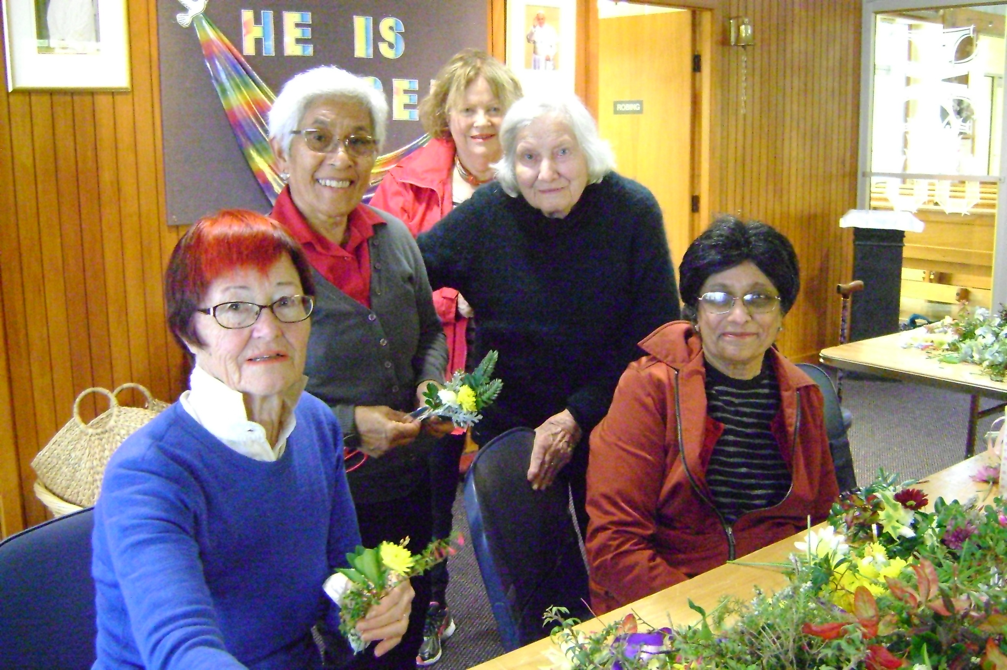
Photos from our posy making afternoon for Mother’s Day 2019. 300 posies for 6 Masses.
Pictured from LtoR:
Ethne Wyndham-Smith, Temara Presland, Penny Dravitski, Anne McIntyre and Gemma Pereria.
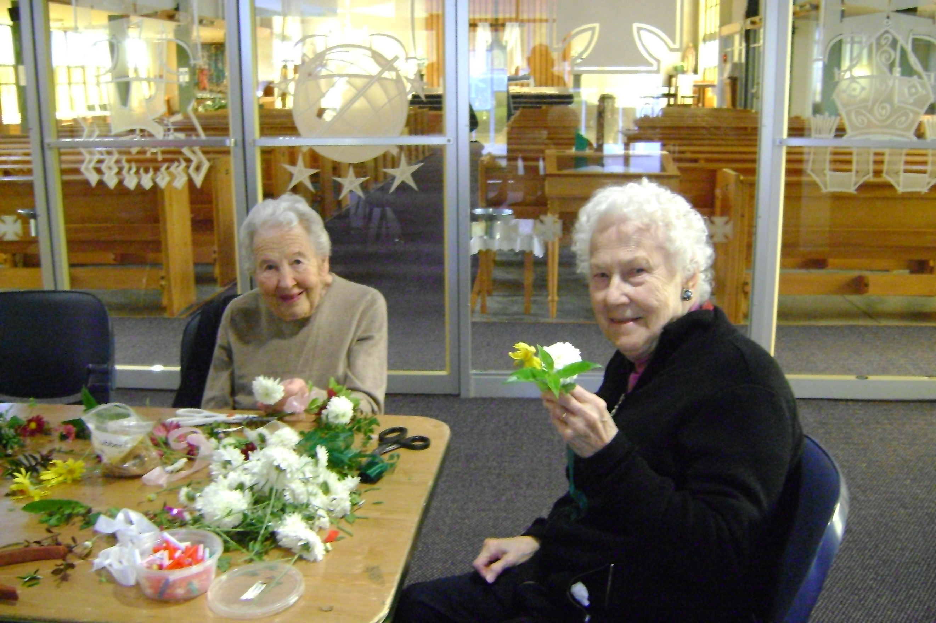

Monica Smith and Margaret West

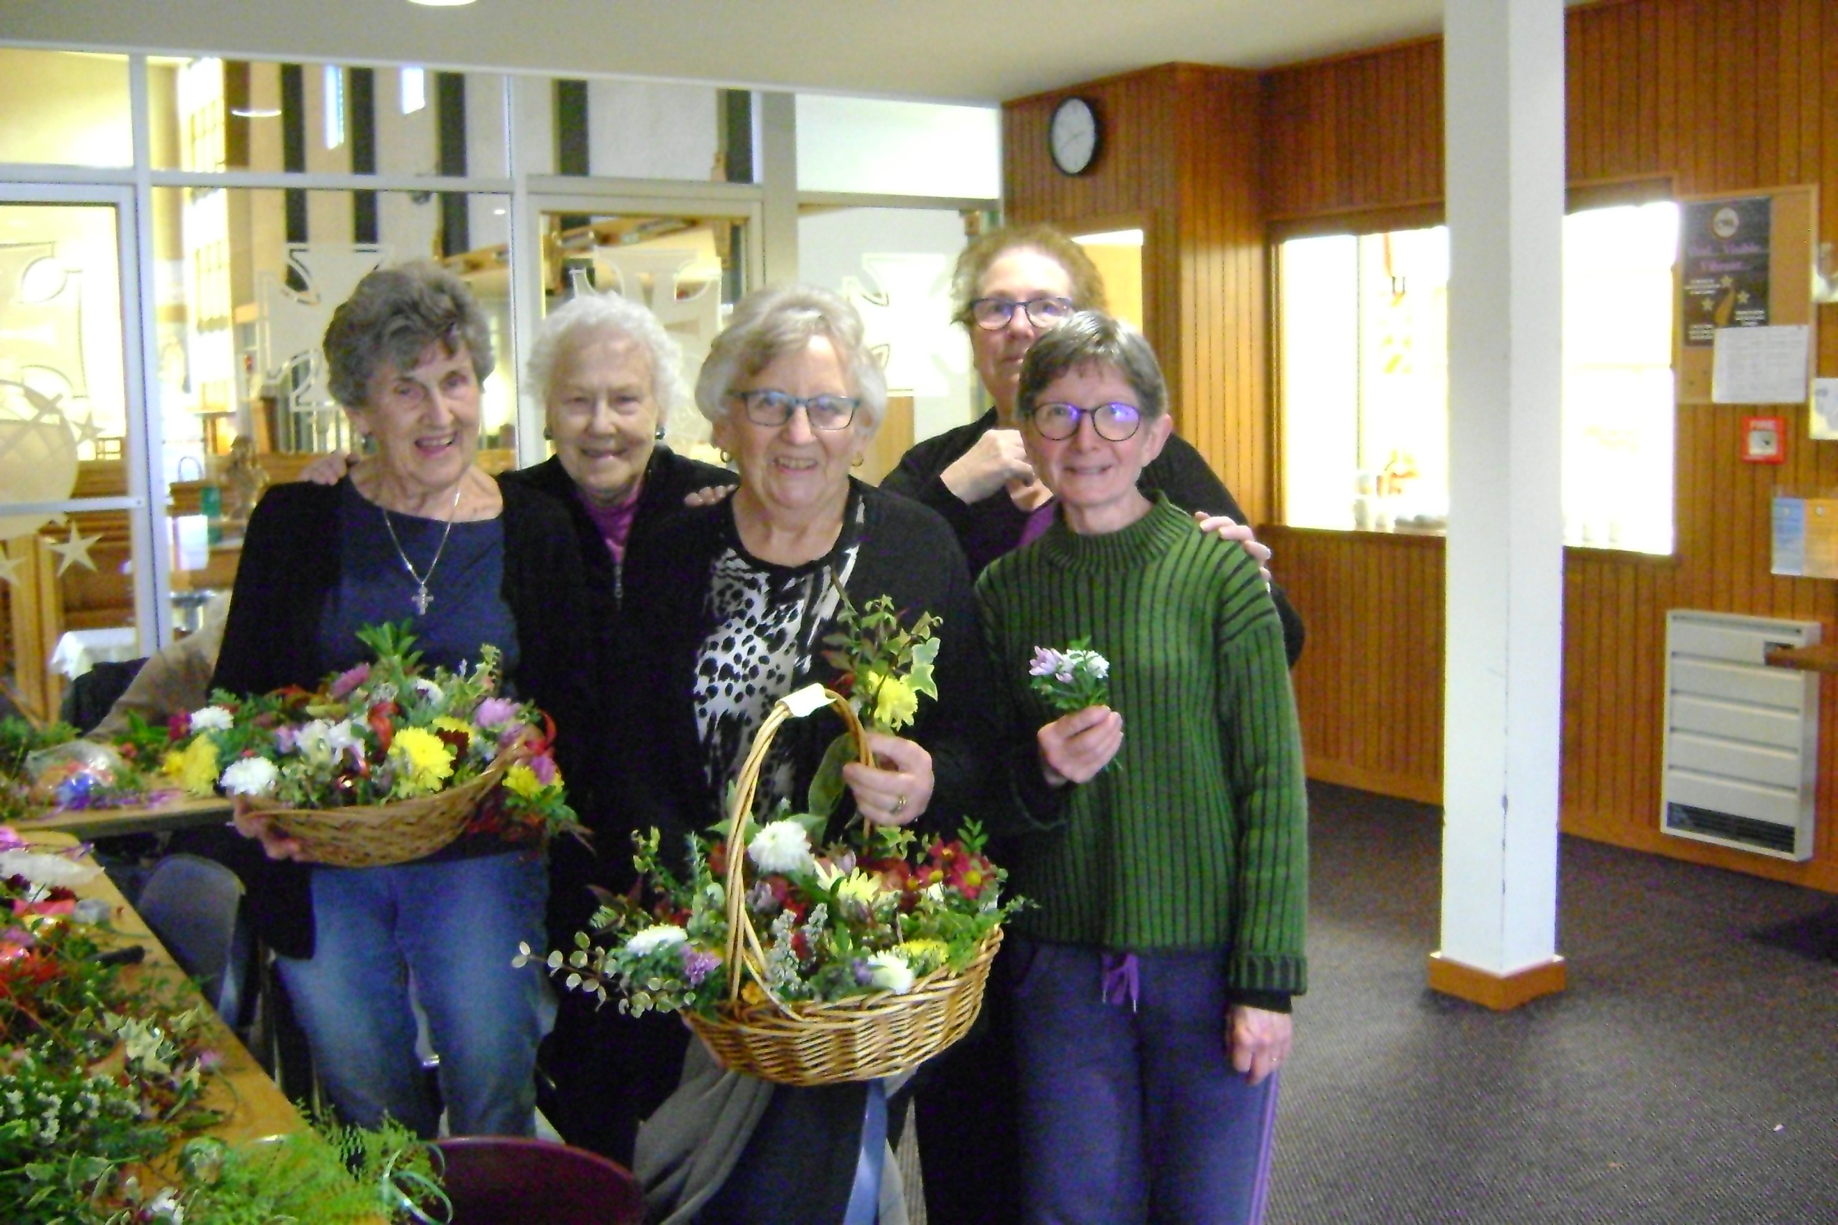

Vonnie Nunns, Margaret West, Anne Williams, Diane Glynan and Estelle Henrys.

