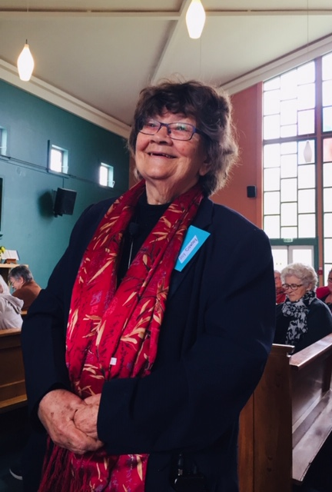
WelCom story December issue
It was wonderful to see in excess of 80 women attending the CWL Archdiocesan Council-organised Day of Reflection ‘Living in Gratitude’ facilitated by Joy Cowley at Our Lady of Grace Church, Heretaunga. Monday Nov 9th. This was open to all parishioners to attend. Organised initially by CWL Chaplain Christine Paterson ably assisted by Kathleen Emmerson, Heretaunga, for all the organisation work ensuring the success of the day. National President Susan Dickson joined us all the way from her home in Methven. Eight women travelled from their New Plymouth and Inglewood Branches to be with us and were billeted by Wellington CWL members. The day was split into three sessions: Women in the Gospel, Women in the Church, Women in the World. Joy opened up our thinking about these topics with humour, discussion and personal reflection. “As women of faith in the Catholic Church, we recognise that women have given birth to all the Church, beginning with Mary, the mother of our Lord. Every Pope and Cardinal, every member of a Vatican Council, every Priest, has come into being through a woman. We are the life givers of the Church. It is enough for us to know this”. A paragraph taken from the handout Joy distributed at the end of the day.
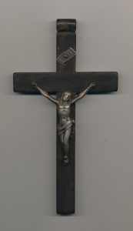
My own personal takeaway from the day was Joy’s description of the Cross. The vertical straight line depicting men and the horizontal line depicting women. The explanation being that most men steer towards independence which is important and the ego supports competition and ambition, therefore vertical. Women on the other hand, steer towards relationship and connection, and social growth which tends to be horizontal. ‘Women in the World’ was unfortunately cut a little short as time ran out, but enough for Joy to reflect on three women, each with very worldly ambitions. St Teresa of Avila, Teresa of Calcutta and Suzanne Aubert. Women who defied the odds to deliver care and an unfailing outreach of faith. The day was a wonderful end to the unprecedented year of change we’ve all had to endure.
Our focus for 2021 continues with the At Home Appeal, this year being 'Days for Girls' a worldwide charitable organisation empowering women and girls through sustainable menstrual care and health education. Our Council Members, spearheaded by the efforts and vision of our President Susan Lloyd for CWL to be more visible and actively involved in the community, have visited a number of secondary and year 7 and 8 primary schools in the Wellington region acting as ambassadors for 'DfG' delivering Health Kits, promoting the health care where it is needed. The annual Archdiocesan Conference is in March, hosted by Kapiti Region at Our Lady of Kapiti Parish and will feature a school debate by Bishop Viard College students, debating the current CWL theme: Kia Kaha-Courage Take Heart. The CWL wishes everyone a Happy Christmas and safe travelling. Karen Saunders
Pictured: Suzanne Aubert’s Cross and Joy Cowley.

