
Catholic Women’s League Upper Hutt Branch
NEWSLETTER

Committee Members
President
Susan Lloyd
Ph 970 3730
vancara42@gmail.com

Correspondence Secretary
Christine Macartney
Ph 971 8712
frankchrismac@gmail.com

Minute Secretary
Val Kelly
Ph 970 6450
frankvalkelly@gmail.com

Treasurer
Lorraine Sayer
Ph 970 6075
lorraine.joy.sayer@gmail.com

Committee Members
Teen Parent Liaison
Val Kelly
Ph 970 6450
frankvalkelly@gmail.com

Photographer
Brenda Neville
Ph 021 0493104
b.neville@xtra.co.nz

Shirley Allen
Ph 5279494

Anne McGrath
Ph 021 08046998
annemcgrath2@yahoo.co.nz

Nellie Boynton
Ph 938 2512
scotsgirlsnell@outlook.com

Outside Committee
Pacific Mission Liaison/
Almoner
Val Hanning Ph 527 7629
valjohn@xtra.co.nz

DEAR MEMBERS

With Easter behind us, we wake up to increasingly brisk mornings. Time to change the sheets and think about having our anti-flu injections!
…… to all those who attended the recent CWL Fun Quizz, donated prizes and provided supper. We are forever grateful. It was lovely to see so many new faces among the participants. Great to have a number of our CWL members from the Otari, Lower Hutt and Heretaunga Branches supporting our fundraiser. The $1,435 profit will be divided between the St Vincent de Paul Upper Hutt and the NZ Down Syndrome Assn.

On 19th May, Sybil Murphy reaches the milestone of 100 years of age. A big CONGRATULATIONS from us all. Sybil is now residing in the Home of Compassion, Silverstream.
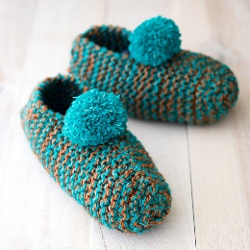
To all those wonderful knitters who have produced 25 hats, 48 pairs of slippers and 21 pairs of gloves so far, we acknowledge with thanks the commitment of time and energy that you have given. These will be distributed to schools when the current holidays are finished. Please continue clicking those knitting needles! So much appreciated.

2022 Wellington Archdiocesan Conference has been set down for 16/17th March in New Plymouth. To assist get as many members as possible to the event, your Committee have decided to run a fundraiser in the form of a Lotto Bonus number. If you would like a number from 1-40, the cost will be $10 for five weeks. Let your group leader know your preference or ring me.
2021 CWL National Conference is in Rotorua on 22-24 July 2021 at the Millennium Hotel. “Celebrating who we are and what we do”. Theme of “Kia Kaha – Courage, take heart”.

Nellie Hudepohl’s funeral was held at St Joseph’s Church on Friday, 16th April. She joined the Catholic Women’s League in 1957 and was a member of our Branch for 47 years. Thank you to those who helped serve refreshments. Eternal Rest Grant to her O Lord. May she rest in peace!
World Union of Catholic Women’s Organisation (WUCWO) It was exciting news that Pope Francis chose February to focus his praying for women who are victims of violence. This is in line with one of WUCWO’s third resolution for the next four years. Let us eliminate discrimination and violence against women. The WUCWO Day prayers for May 2021 have arrived and they have been prepared by the women of the Northern American Region. We will be celebrating 110 years of WUCWO at the CWLANZ National Conference.
Teen Parents Soup Days will be starting on Wednesday, 12th May. We would love to have some soup makers please. Also needed is help to serve the soup for one hour every second Wednesday during the forthcoming winter term. If you are able to go on a roster for either making or serving the soup this would be much appreciated. Please ring or email Susan. STOP PRESS!!! As a result of a recent Government announcement re provision of free meals five days per week as from the third term this year, after 19 years working with Teen Parents, our Branch will be finishing the association at the end of the second term. The above request for soup makers and serving soup helpers is only for five more occasions! As a Branch it has been a wonderful experience to help out and witness the mother’s progress into education opportunities. Many thanks to Val Kelly for leading this project from start to finish.

Milo Days at St Joseph’s School. We are hoping to start this activity again on each Monday from 10th May and running through the two winter terms. This will be during the school morning tea break. Volunteers to serve the Milo on a roster, please ring or email Susan.
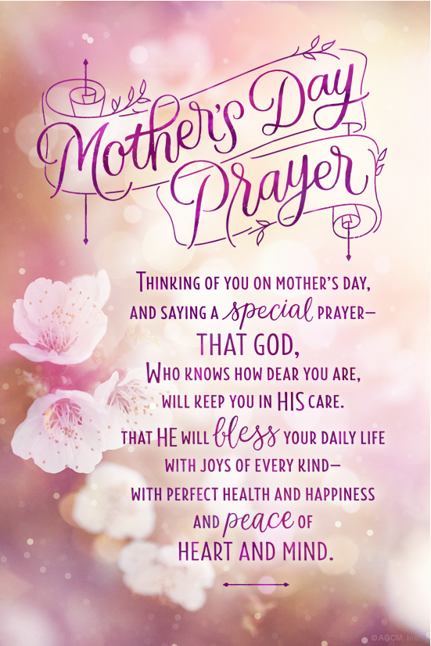
Speakers for our Monthly Meetings If any member has a suggestion going forward, please do not hesitate to inform any member of our Committee. It is always helpful to have a small “pool” that we can draw upon and extend invitations to them. Ideas most welcome!

Sunday, 9th May

On behalf of our Committee,
best wishes to you all for a
Happy Mother’s Day

Susan Lloyd, President

